Internal Validity (Plan 5) -

EMSE 6577

Drew Gobbi, Olivia Wang, Olatunji Akinbule, Maddie Warndorf

1. **Describe in detail the causal theory underlying your analysis. What are the proposed causes and what are the proposed effects?**

As discussed in our previous presentation, we believe demographic features such as poverty status, whether a person is middle aged, education level, employment status, and household income may be associated with higher incidences of opioid use in census tracts within Tempe. In our study, we extract these demographic features from the United States Census’ American Community Survey five-year (ACS5) estimates and compare them to daily measures of the population normalized mass load (PNML) of opiates in wastewater to determine if this relationship exists. We will stop short of calling any relationship found, “causal”, and instead argue that these associations may represent risk factors that could lead to higher incidences of opioid use within the city.

1. **Show pilot data demonstrating some statistical relationship, including temporal precedence and covariance between your proposed cause and effect.**

Beyond daily volatility, we observe a near constant mean in the PNML estimates across the two years of measurement we have in our sample. The ACS5 variables are held constant over this period, so we are assuming that temporal precedence is not an applicable factor in this analysis. As such, we expect relationships between predictive demographics (or other predictors that are shown to be time-constant over this period) to have a consistently higher correlation and/or impact on drug use compared to other factors. We do observe some cyclicality in the PNML that could be worth investigating further in the future. However, we find that the entire series is time stationary.

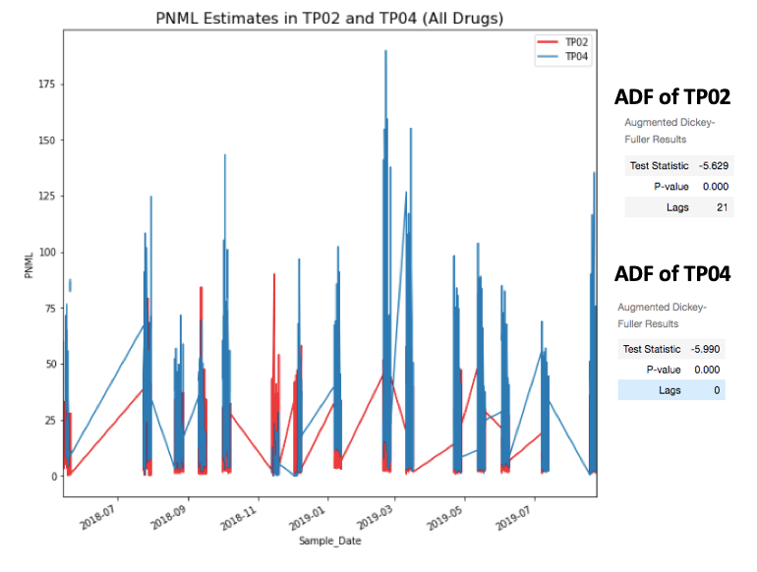

In terms of an actual statistical relationship goes, we find that the hypothesis we originally proposed does not have an impact on the PNML measures of Opioid uses in our data. This is highly concerning, but after a further view of the literature not unexpected. Researchers have generally struggled to find consistent demographic correlates with opioid use due to the various measurement confounds discussed in the previous sections.

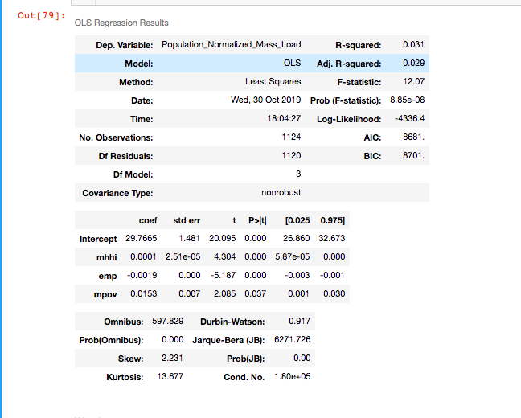

The Arizona Department of Public Health has published some preliminary findings suggesting that features such as gender, mental health factors or a history of substance abuse may have significant relationships with opioid usage. We have requested access to a 2018 release by the Arizona Public Department of Public Health that contains some of these statistics. We are also in the process of identifying mental health measures for our analysis but are having difficulty finding these measures at the city or census tract level.

We have also obtained geo-spatial point estimates of several different behavioral treatment and health care centers within tempe that we plan to include as spatial regressors (i.e. number of X centers within Y miles of the tract centroid) in our analysis. We expect these to have a negative impact on opiate use.

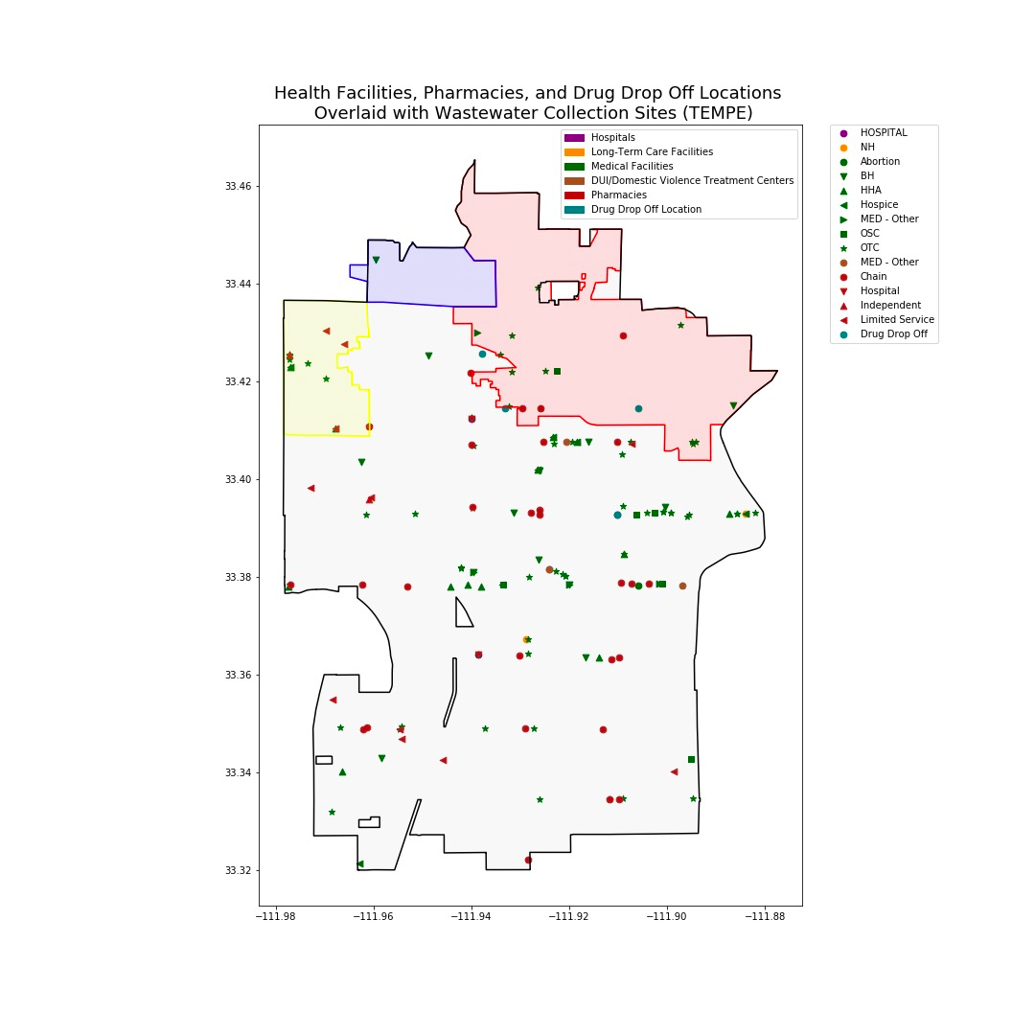

1. **For each possible type of threat to internal validity, indicate whether your analysis is susceptible.**

History Confound:

The data are gathered daily, so we do not think there will be specific events happening between every two days that would lead to significant differences in measurements. While we do observe a degree of inter-day volatility (shown in the chart above), tests of stationarity show that measurements are constant (i.e. not time-dependent) throughout our sample.

Maturation Confound:

We do not observe a trend in our data, which suggests that they are not changing as a function of time. Because we find the series to be stationary, we do not see the maturation confound as a concern.

Testing Confound:

The data are gathered through wastewater, so that the researchers are not directly interacting with the people who are using/abusing opioid, in which case, it is very unlikely that they know experiments are being done on them, and even if they do know, they will not be able not to use restrooms which means that their behaviors will be very unlikely to change. Also, by gathering wastewater sample and testing on the wastewater, researchers are not changing the wastewater in any way, in which case testing confound is not a concern here.

Instrumentation Confound:

The instrumentation confound is a major threat to our analysis because we do not know the detection threshold for the tools that the researchers are using to get the PNML estimates. In other words, PNML estimates may miss low quantities or certain types of drug use based on the way they are measured. Because we do not directly control the source data and measurements there is an inherent and consistent instrumentation confound in our analysis.

Statistical Regression Confound:

The stationarity of the time series suggests that the data we are collecting regressess about its mean appropriately.

Experimental Mortality:

Because the measurements are conducted on waste water, unless there is a major migration from one area to another or a major overdose that leads to many fatalities in a specific area the experimental mortality is not a concern in our experiment

Multi-group threats:

We are not assigning people to the groups/areas, and Tempe is relatively small as a city which also has a major problem of opioid abuse, in this case we might consider the population in Tempe normally and randomly distributed among the three areas that we are studying and the multi-group threats should have little impact

Selection-X threats:

We do not anticipate selection-history, selection-maturation, selection testing, instrumentation, or regression threats in our study. As discussed previously, the time-constant mean of the PNML measures suggests that each collection area does not differ much between the high frequency observations in terms of history or maturation. We do not face a selection-testing threat because we are not introducing a specific intervention into the dataset. Likewise, we do not face a selection-instrumentation threat because all measures in our dataset are affected by the instrumentation confound into the dataset.

The only potential selection-x threat we could face is selection-mortality. Subjects in high opioid use collection areas for example may have a greater incentive to move out of the sampling frame during our study than subjects in areas that do not face these issues.

Social Threats:

Subjects in each collection group can not observe who is in which collection area and so they do not have an incentive to modify their behavior.

The few threats that our analysis might be susceptible to are:

Instrumental Confound, Experimental Mortality and Selection-X Threats(specifically Selection-Mortality threat)

1. **For each threat for which your analysis is susceptible, indicate whether that threat is plausible.**

The instrumentation confound is a plausible threat to our analysis that we are unable to eliminate. Because our study is solely based on the measurements gathered by the ASU researchers and their methodology is not published, we are unable to state the degree of bias we face from the instrumentation confound. Therefore, we have to accept this risk when conducting our study. This instrumentation confound is at least constant across all PNML estimates, and would similarly be present in other opioid measures such as emergency services calls. As such, we consider this risk acceptance to be appropriate because we have no other options for a cleaner measurement.

While we do think that the experimental mortality and the selection-Mortality threat could be plausible, we do not expect it to have a significant impact on our study. Unless there is a major population shift from one area to another or a major health event (i.e. overdose spike) we do not expect our sample to change much during our study. We consider this particularly unlikely because we are looking at only a few years of data where we do not expect sample characteristics to change much absent a significant event.

As for Selection-X threats as a whole, the areas are closely located and we can expect some spillover between and among areas, in which case the groups/areas will not have significantly different characteristics themselves, in which case, the difference in opioid concentration in different areas is not likely caused by the characteristics internal of the groups. We plan to address these effects by including spatial regressors in our analysis.

1. **Choose an experimental design to rule out plausible threats, assuming you can manipulate all units of analysis and conduct random assignment. Your design should allow you to rule out all plausible confounds.**

In a perfect Tempe World, we would have all of the PNML for every tract. Then we would randomly assign which tract we would measure opioid usage based on PNML and randomly assign which tract we would measure opioid usage based on EMS Opioids Calls.

The experimental design that could be done in a Perfect Tempe World where we could conduct random assignment for which census tracts are being measured with PNML and by EMS opioid call would be a Posttest-Only Control Group Design. The setup for this experimental design would be:

|  |  |  |
| --- | --- | --- |
| Randomly Assigned Tracts (R) | Opioid Usage Data from Tracts Measured by PNML (New Opioid Measurements) Being Published (X) | Observe Community and City Policy Effects (O) |
| Randomly Assigned Tracts (R) | Opioid Usage Data from Tracts Measured by EMS Opioid Call Data Being Published (Control because they have been publishing this data longer) | Observe Community and City Policy Effects (O) |

We can have more proxies for our opioid use construct to rule out potential instrumental confound, and if we see the same or similar trend over time in the same area and across areas we could potentially mitigate the instrumental confound that we have, but we do not have an efficient way to completely eliminate instrumental confound.

1. **Can you do random assignment of subjects? If not, why not?**

Random assignment involves randomly assigning subjects into different groups so that across different groups the characteristics of groups are not causing the differences observed in the experiment . Our study cannot randomly assign subjects into specific groups/areas because we have no control over which subject lives in which area. Our study does not need to randomly assign subjects either because we are not directly introducing a treatment to the population. We are merely observing opioid use through the PNML or EMS estimates in a given area and noting what features of that area may be correlated with those opioid estimates.

1. **Given your answer to the previous question, which plausible threats to internal validity are you unable to address?**

Because we are not randomly assigning a subsample to a specific intervention, any association we observe is assumed to be merely suggestive and not causal. This is because we cannot rule out potential self-selection of the population into the census tracts in Tempe we are observing. This may bias our estimates. Similarly, we are also susceptible to potential spillover effects between watersheds in the collection areas that may over or understate the effects of a given characteristic on opiate use in the census tracts we are studying. We are also unable to make the distinction between prescribed and unprescribed use of opioids in our PNML estimates because we are only observing total usage in the city wastewater.

1. **Propose a combination of quasi-experimental designs you might use to mitigate the remaining threats to internal validity.**

We propose using an equivalent materials quasi-experimental design to test the effects of demographic features on opioid use in Tempe. We will test the effects of the same demographic predictors on different measures of opioid use such as the PNML wastewater estimates and the EMS call data. While there is no explicit control group here, a determination of a consistent relationship between the same group of certain community factors and different proxies for opioid can help bolster our claim that these risk factors are enduring.

For this reason, we would use the Equivalent Materials Design mixed with a Patched Design.

|  |  |  |  |  |  |  |  |
| --- | --- | --- | --- | --- | --- | --- | --- |
| Census Tracts within Wastewater Collection Sites  (N) | Observe breakdown of selected Factors (ages for now)  (O) | Opioid Usage Measured by PNML  (MaX1) | Observe which age group has higher PNML based on location within the wasterwater collection site.  (O) |  |  |  |  |
| Census Tracts within Wastewater Collection Sites  (N) | Observe breakdown of selected Factors (ages for now)  (O) | Opioid Usage Measured by EMS Opioid Related Calls  (MbX1) | Observe which age group has higher EMS calls based on location within the wasterwater collection site.  (O) |  |  |  |  |
|  |  |  |  | Census Tracts **not** in Wastewater Collection Sites (N) | Observe breakdown of selected Factors (ages for now)  (O) | Opioid Usage Measured by EMS Opioid Related Calls  (MbX0) | Observe which age group has higher EMS calls based on location **not** in the wasterwater collection site.  (O) |

1. Discuss how you would rule out OR measure the size of these remaining threats

We have Instrumentation Confound that we will not be able to rule out, but we can measure the size of the Instrumentation Confound with some other data. For example, with the health facilities, pharmacies and drug drop off locations overlaid with wastewater collection site data, we can look for research that has already been conducted related to the level of supervised/subscribed opioid use related to each facility type and measure the size of some of the instrumentation confound in this way.

We can also try getting in touch with the researchers in ASU to ask them about their way of measuring the wastewater opioid data, with which information we will be able to know the detectable threshold they are using, and we can cross-reference research done regarding the measurements of wastewater opioid data and their accuracies to measure the size of the instrumentation confound.

As for Experimental-Mortality Confound, we can keep monitoring the census data overlaid with the census tracts to closely monitor the change in population in different areas. However, because the census is not done in the same frequency as the wastewater opioid detection, we will have to make sure that they are on the same frame. Or, if the census data show that in the long run, the population in each and all areas are largely consistent, then we can rule out the Experimental Mortality Confound.

1. Demonstrate your proposed experimental or quasi-experimental design on pilot data.

|  |  |  |  |  |  |  |  |
| --- | --- | --- | --- | --- | --- | --- | --- |
| Census Tracts within Wastewater Collection Sites  (N) | Observe breakdown of selected Factors (ages for now)  (O) | Opioid Usage Measured by PNML  (MaX1) | Observe which age group has higher PNML based on location within the wasterwater collection site.  (O) |  |  |  |  |
| Census Tracts within Wastewater Collection Sites  (N) | Observe breakdown of selected Factors (ages for now)  (O) | Opioid Usage Measured by EMS Opioid Related Calls  (MbX1) | Observe which age group has higher EMS calls based on location within the wasterwater collection site.  (O) |  |  |  |  |
|  |  |  |  | Census Tracts **not** in Wastewater Collection Sites (N) | Observe breakdown of selected Factors (ages for now)  (O) | Opioid Usage Measured by EMS Opioid Related Calls  (MbX0) | Observe which age group has higher EMS calls based on location **not** in the wastewater collection site.  (O) |

Again here is our plan. We have to re-work which factor that we want to do but for the sake of this demonstration we will stick with age.

For PNML within Collection Sites:



For EMS Opioid Calls within Collection Sites:

|  |  |  |  |
| --- | --- | --- | --- |
| Census Tracts within Wastewater Collection Sites  (N) | Observe breakdown of selected Factors (ages for now)  (O) | Opioid Usage Measured by EMS Opioid Related Calls  (MbX1) | Observe which age group has higher EMS calls based on location within the wastewater collection site.  (O) |

Area2:

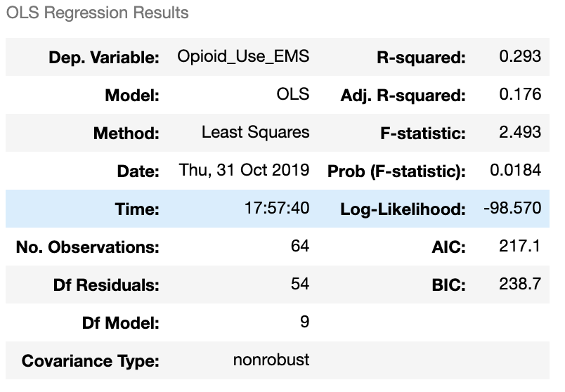

Area 4:

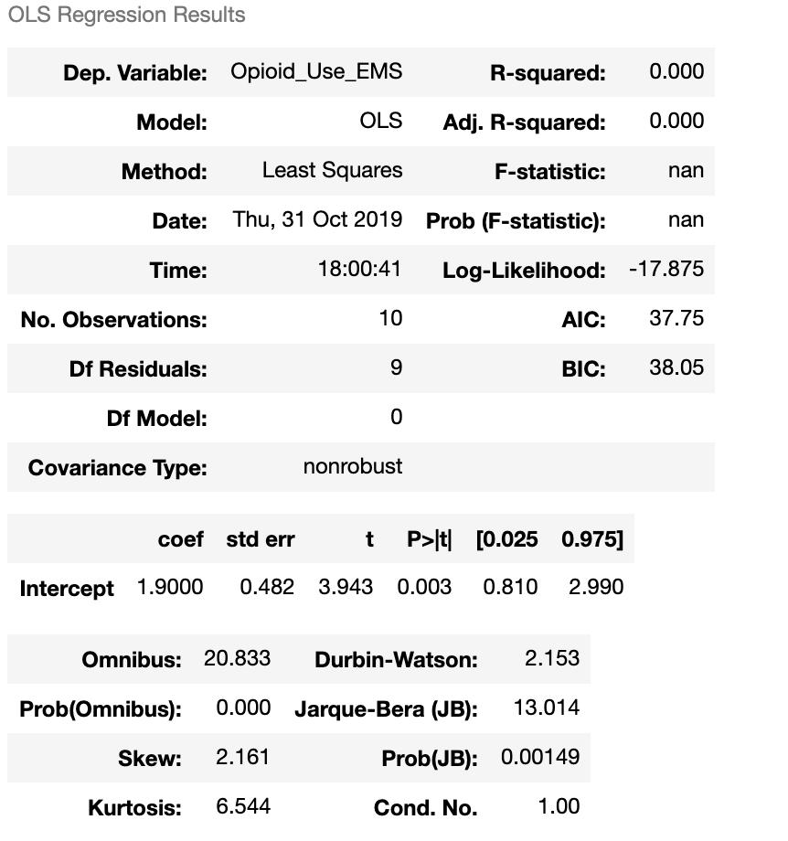

Area 5

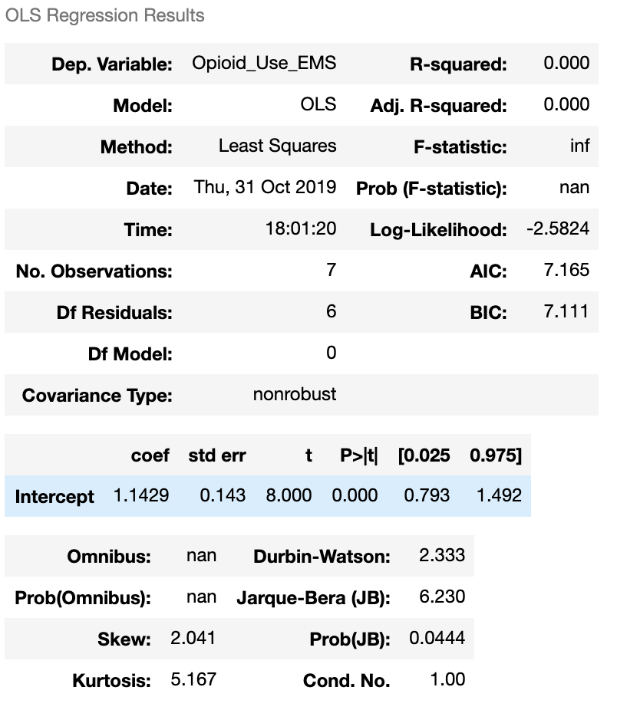

For EMS Opioid Calls in Non-Collection Sites:

|  |  |  |  |
| --- | --- | --- | --- |
| Census Tracts **not** in Wastewater Collection Sites (N) | Observe breakdown of selected Factors (ages for now)  (O) | Opioid Usage Measured by EMS Opioid Related Calls  (MbX0) | Observe which age group has higher EMS calls based on location **not** in the wastewater collection site.  (O) |

